Ideation Phase
Define the Problem Statement
Date | 29 September 2026
Team ID | SWTID-2026-2597
Project Name | Streamlining IT Procurement – Automating Standard Laptop Orders with Flow Designer
Maximum Marks | 2 Marks
Customer Problem Statement Template
The problem statement describes the customer's point of view and clearly identifies the goal, barriers, reasons for the barriers, and resulting feelings in the Standard Laptop procurement process.
Problem Statement
I am (Customer) | An IT procurement team member / employee requesting a standard laptop.
I'm trying to | Request a standard laptop quickly and track its progress.
But | Configuration tasks can be delayed or missed when handled manually.
Because | The process depends on manual task creation and assignment.
Which makes me feel | Frustrated by delays and uncertain about the configuration status.
Project-Specific Problem Statement
Standard laptop requests require an automated task-creation and assignment process so that laptop configuration can start promptly after approval, reducing delays and manual intervention.
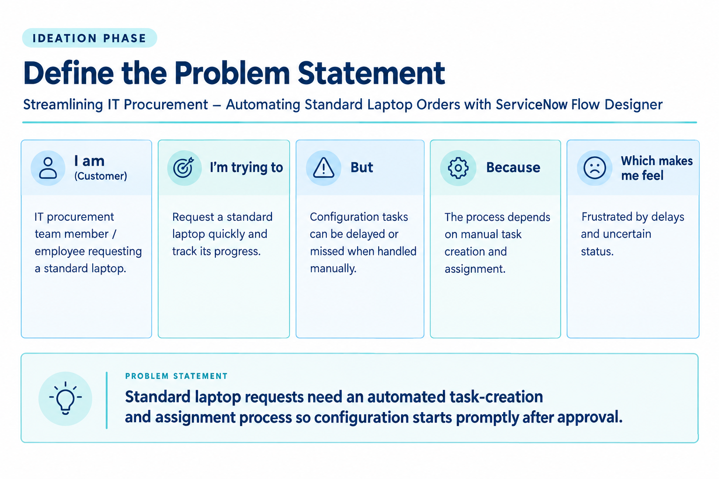
Figure 1. Customer problem statement canvas for automated laptop procurement.

